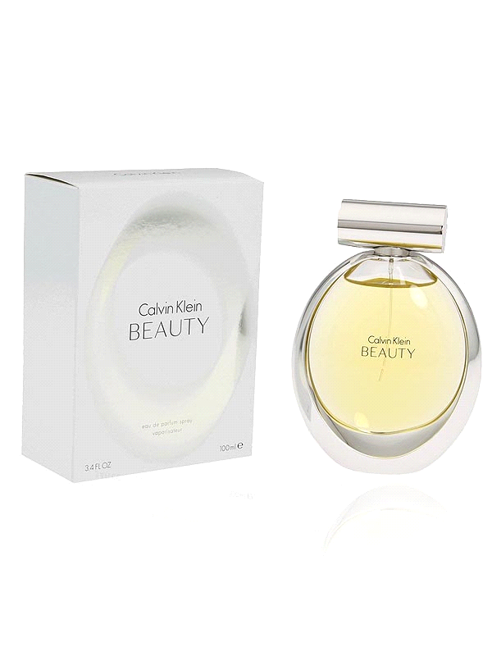

This perfume market a revolutionary turning-point in the house of Burberry. Roberto Menichetti became an artistic director in 1998. With his arrival some serious changes had been made; a more modern style was implanted without being unfaithful to Burberry’s original This new floral fragrance evokes the power of femininity and sophistication. A new interpretation of a lily is at the heart and soul of this delicious scent and to bring the neo-lily to life, this fragrance contains ambrette seeds which enhance the spicy warmth. Heart notes of timeless jasmine elevate the floral signature and a trail of cedarwood brings a vibrant and magnetic beauty CK Beauty.

Brand Name: Calvin Klein

Product Code: SHL-Ck-5654

Quantity (ML) 100 ML

Made: Imported

Gender: Female

Price: Rs.2,699/-